**Installing MySQL on MacOSX – TWO OPTIONS**

**Installation using Homebrew (RECOMMENDED):**

The easiest way to install MySQL on mac is to use homebrew. In order to use homebrew

you have to install it first. Visit http://brew.sh/ for instructions on installing it. Basically

you copy the command from the website and paste it into terminal (Finder > Go >

Utilities > Terminal) and hit enter and follow the instructions.

*Note: If you are running El Capitan (Mac 10.11) or you will be prompted to install*

*command-line tools, tell it to do so. If you are using an older version you need to install*

*xCode command-line tools first. Visit https://developer.apple.com/downloads/ if this is*

*the case.*

After homebrew installed on your system you can use it to easily install programs from

terminal (You can even install applications like Google Chrome, Firefox, or pretty much

any other free application available for Mac).

To install MySQL with Homebrew do the following:

1. Open a new terminal window (Finder > Go > Utilities > Terminal).
2. Enter the following command:  
   brew install mysql
3. When it finishes installing we need to start MySQL. You can configure MySQL to always start when you restart your computer by entering the following command into the terminal:  
   ln -sfv /usr/local/opt/mysql/\*.plist ~/Library/LaunchAgents
4. Finally enter this command to start MySQL without restarting your computer:  
   mysql.server start

Depending on the install, some users may need to write out the full install folder location:

sudo /usr/local/mysql/support-files/mysql.server start  
sudo /usr/local/mysql/support-files/mysql.server stop  
sudo /usr/local/mysql/support-files/mysql.server restart

1. To login and use MySQL issue the following command in the terminal:  
   mysql -u root mysql
2. To exit mysql, simply type:  
   Exit;

**Installation using download from MySQL Development Site:**

Another way to install MySQL on mac is to use the MySQL developer site. In order to use MySQL, you have to install it first. Visit [https://dev.mysql.com/downloads/mysql/](https://www.google.com/url?q=https://dev.mysql.com/downloads/mysql/&sa=D&ust=1478816248701000&usg=AFQjCNHZcQZ_W95sytGtfbbqe1r7z4pykQ" \t "_blank) for instructions on installing it. You will be given a password upon install and it is very important to keep this password. You can look up later how to change it if you wish.

*Note: If you are running El Capitan (Mac 10.11) or earlier you will be prompted to install* *command-line tools, tell it to do so. If you are using an older version you need to install* *xCode command-line tools first. Visit https://developer.apple.com/downloads/ if this is* *the case.*

*Note: You will have installed MySQL into a different directory than your Desktop/Documents/etc.*

1. Once MySQL is installed, start the server by going into your System Preferences on Mac and double-clicking the MySQL icon at the bottom.

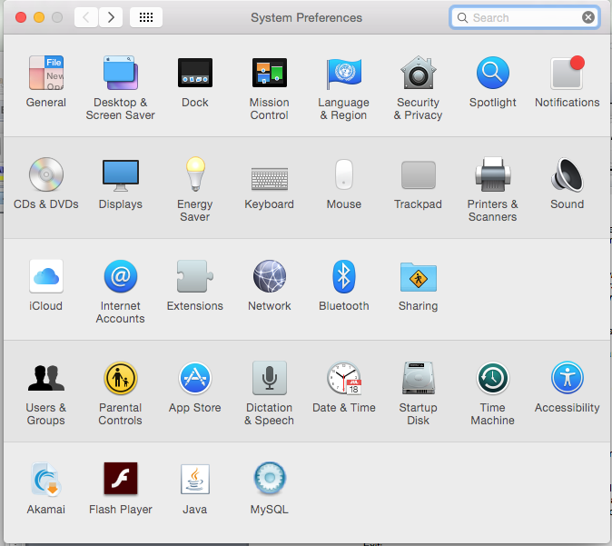

2. You will get a window that says the MySQL Server Status. Check the box that says “Automatically Start MySQL Server on Startup” and then click “Start MySQL Server”.

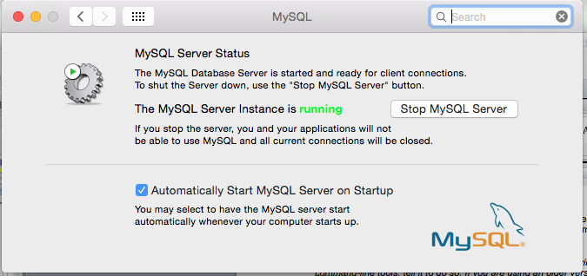

You may also use these commands in the terminal window to start or stop the server:

sudo /usr/local/mysql/support-files/mysql.server start  
sudo /usr/local/mysql/support-files/mysql.server stop  
sudo /usr/local/mysql/support-files/mysql.server restart

3. Log into MySQL by issuing the following commands into a terminal window:

cd /usr/local/mysql/bin

Next:

/mysql -u root -p

4. You will be prompted for a password. Enter the password you were given during install to login.

5. To exit mysql, simply type:

Exit;

Tip: Search the web for how to make a permanent alias to a program. This will make your life much easier instead of typing in /usr/local/mysql/bin/mysql every time!